**// Given a singly linked list of size N of integers, check if the given linked list is // palindrome or not.**

#include<iostream.h>

#include<conio.h>

struct Node{

int data;

Node *link;

};

Node *top=NULL;

void push(int val){

Node *ptr = new Node();

ptr->data = val;

ptr->link = top;

top = ptr;

}

void pop(){

Node *ptr = top;

top = top->link;

delete(ptr);

}

void main()

{

clrscr();

int max,ans,arr[10];

cout<<"\t\t CHECK IF THE GIVEN LINKED LIST IS PALINDROME OR NOT \n";

cout<<"\nEnter the range of the array:";

cin>>max;

cout<<"Enter the values :"<<endl;

for(int i=0;i<max;i++)

{

cin>>arr[i];

push(arr[i]);

}

for(i=0;i<max;i++)

{

if((top->data)==arr[i])

ans=1;

else

ans=0;

pop();

}

if(ans==1)

cout<<"The Given Array Is Palindrome!";

else

cout<<"The Given array is Not a Palindrome!";

getch();

}//void main ends here

**OUTPUT:**

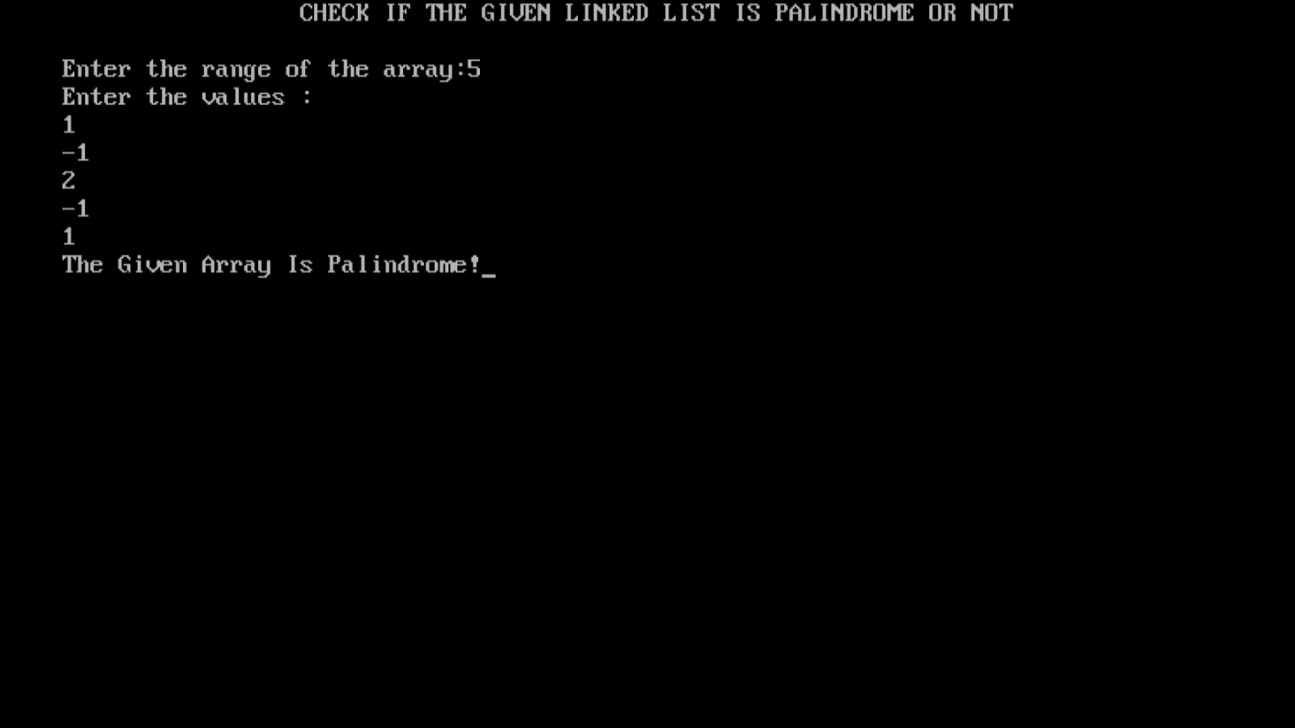

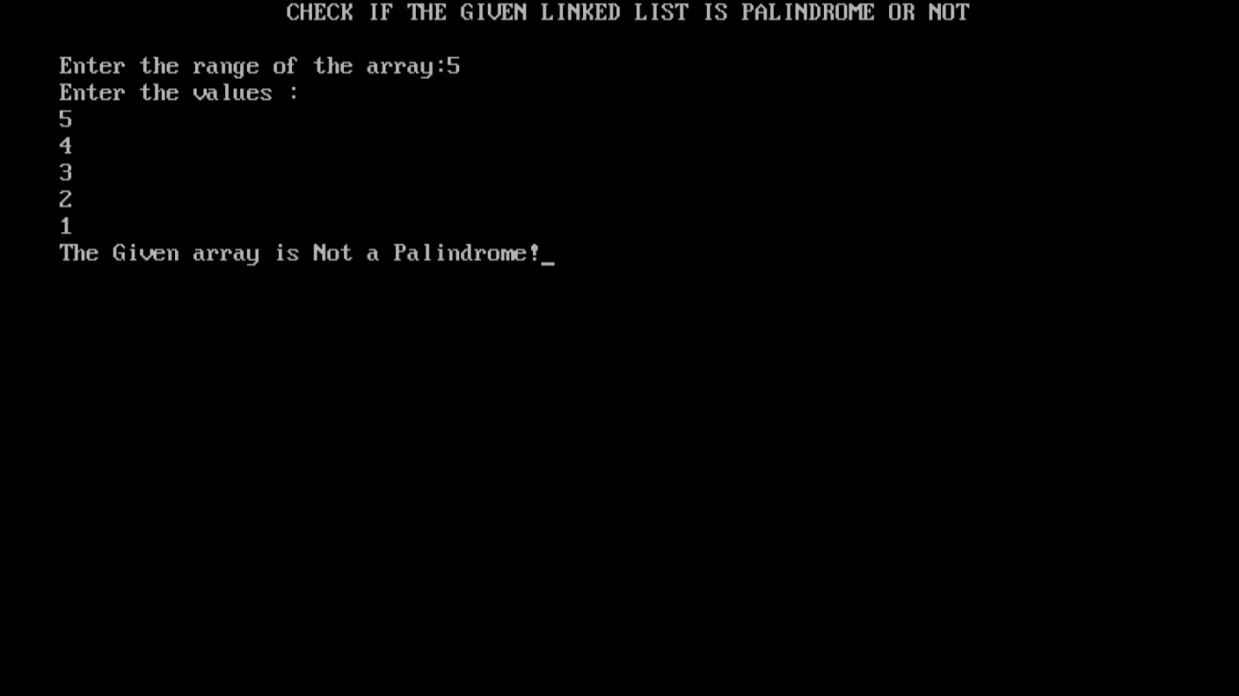

**//This code was contributed by K.Vijeyandrian MCA Section ’B’**